**presenter:**

Name: Itay Chabte

ID: 301839452

Object Oriented Programming - 20586

SmartShop

**May 13, 2021**

# 

**Specification and analysis document**

# 

Table of contents

**Overview** **3**

**Goals** **3**

**System description** **4**

Manager / employee (depending on authorization): 4

Customer 5

System components **5**

**Use Case diagrams** **6**

Customer management 6

Product and order management 7

Workers management 9

Create a connection and purchase 10

**activity diagram** **11**

Product purchase 11

Inventory management 12

**Manual** **13**

Administrator's Guide 13

Manager and employee entry and toolbar change 13

Category Management 15

User Management 16

Product Management 17

Purchase Management 19

Worker Management 21

Store Management 23

Data Analyst Management 24

Exception Management 26

Customer’s Guide 27

Manager and employee entry and toolbar change 27

Sign up 28

Profile management 29

Ordering items 31

Cart and purchase management 32

# Overview

The SmartShop is a platform for small businesses that want to enter the world of online sales easily and instantly

The idea is to give a system to small businesses where they can manage sales, users, employees, etc. in a convenient and easy way and get information to optimize sales in the store

The platform is structured in such a way that it is dynamic for each store but gives the same solution to all the actions required by each basic stores.

# Goals

1. **Introducing to the online world:** Give small businesses the opportunity to enter the online world and ease the management of the business and its users
2. **Independent system:** The platform allows for independent maintenance which means that after initial data entry no further development is required.

Therefore the platform enables customers to place orders and manage account and on the part of the manager / employee, the platform enables convenient control and management.

1. **Simplicity of use:** The purpose of the system is to be very simple to use and interactive for both the customer and the manager / employee

# System description

User system requirements

## **Manager / employee (depending on authorization):**

* 1. Customer management:
     1. Option to add \ delete \ update \ Search a customer
     2. View customer details
  2. Category management:
     1. Option to add \ delete \ update \ Search a category
     2. View category details
  3. Product management:
     1. Option to add \ delete \ update \ Search a product
     2. Fast management of out-of-stock products
     3. View product details
  4. Purchasing management:
     1. View purchase details
     2. Change status to order status
  5. Workers management:
     1. Option to add \ delete \ update \ Search an employees
     2. View employees details
     3. Giving / taking Authorization from employees
  6. Sales analysis management:
     1. Show graph of sales from date to date
     2. Show percentage cut of the products sold
     3. Show graph of comparing sales between 2 products
  7. Store details management:
     1. Initial\ Change Store info
     2. Adding social media(Optional)
  8. Exception management:
     1. Show Exception when occurred

## **Customer**

* 1. Account management:
     1. Change details
     2. Change password
     3. View Purchase History
  2. Purchasing system:
     1. Add product to cart
     2. Remove product from cart
     3. Confirmation of purchase and checkout
  3. Customer registration:
     1. Login\Logout
     2. New registration if not registered

# System components

1. Frontend - runs on Customer/Manager/Workers platform, both Manager/Workers and customers access the platform via the front end, no additional installations required.
2. Server that runs all the business logic.
3. Databases - that runs on sql server platform, can be changed.

# Use Case diagrams

## **Customer management**

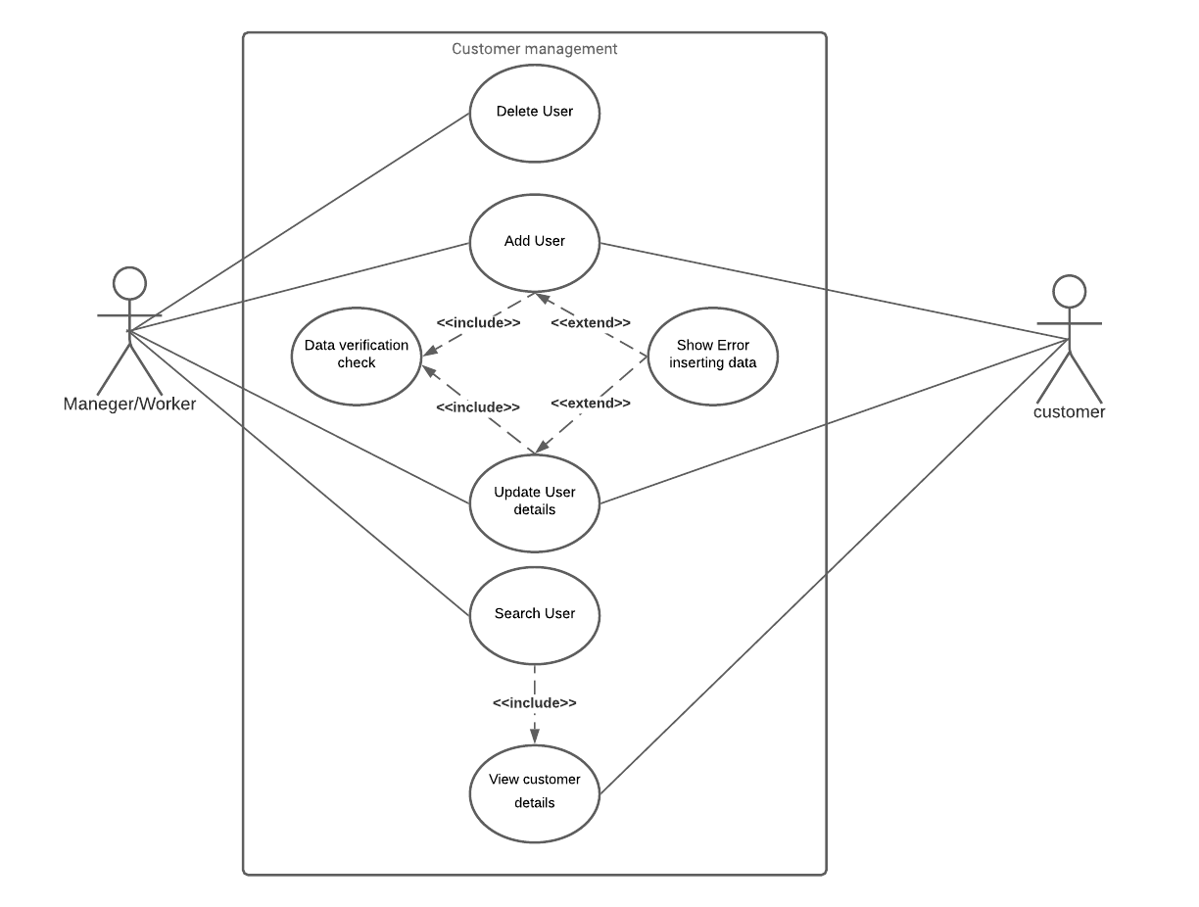

* 1. Manager/Worker add new customer only if the details are valid.
  2. Manager/Worker delete existing customer.
  3. Manager/Worker update existing customer only if the details are valid.
  4. Manager/Worker Search existing customer.
  5. Customer registered only if the details are valid.
  6. Customer updates his details only if the details are valid.

## **Product and order management**

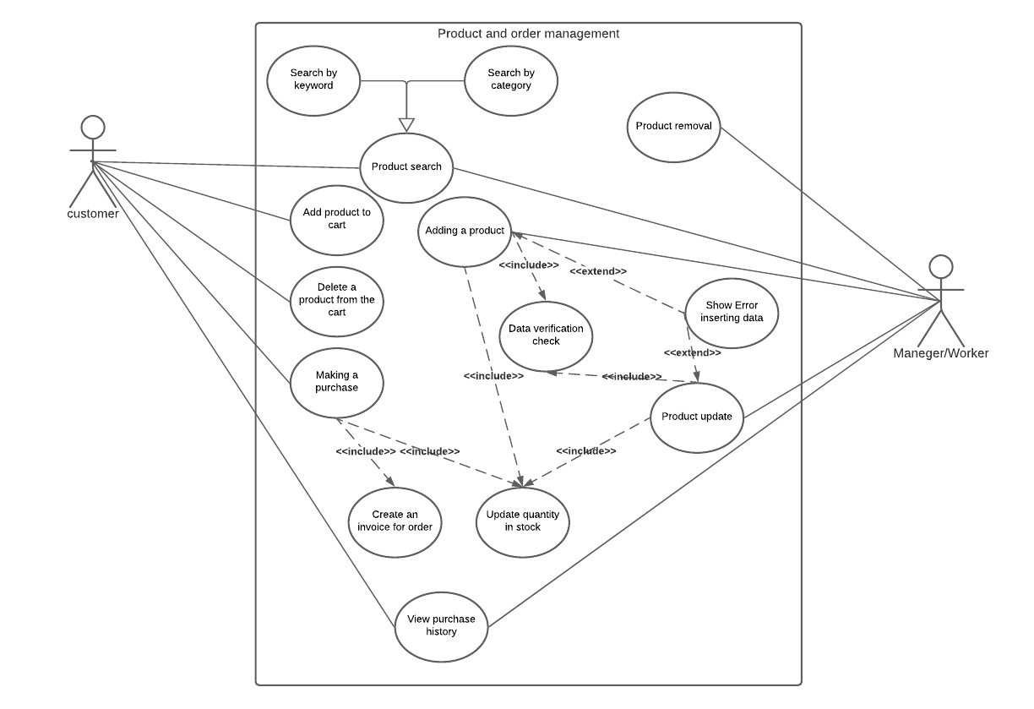

* 1. Manager/Worker add new product only if the details are valid ,and by doing so the quantity is updated.
  2. Manager/Worker delete existing product.
  3. Manager/Worker update existing product only if the details are valid ,And by doing so the quantity is updated.
  4. Manager/Worker Search existing product By keyword or category.
  5. Customer Search existing product By keyword or category.
  6. Customer add/delete product from cart.
  7. Customer making a purchase ,And by doing so the quantity is updated and an invoice is created
  8. Customer can View purchase history
  9. Manager/Worker can View purchase history

# 

# 

## 

## **Workers management**

[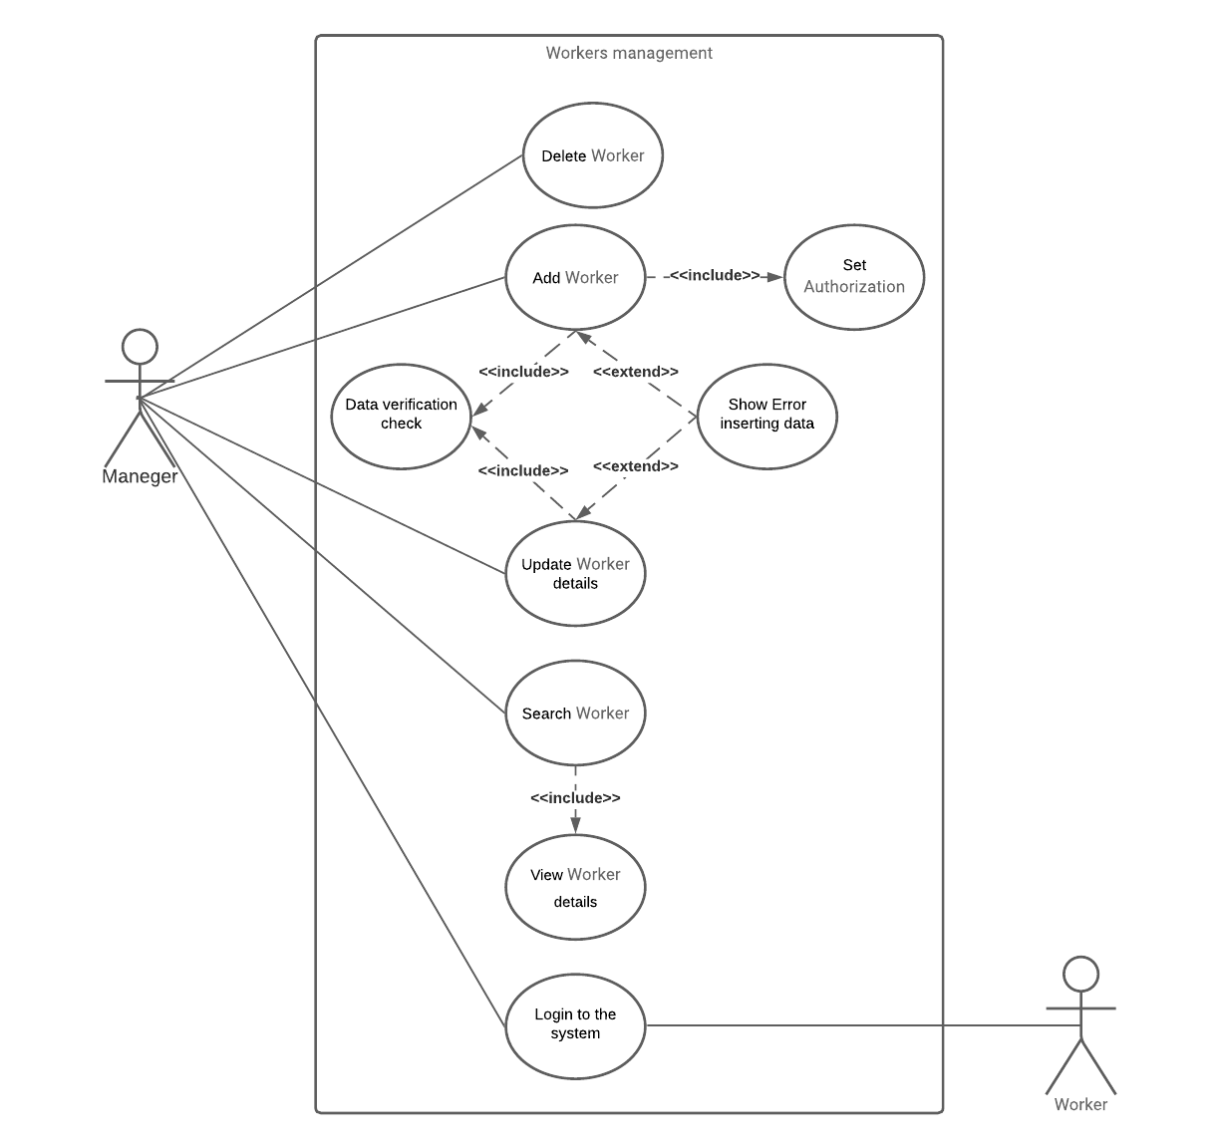](https://lucid.app/documents/edit/b62c02e0-64d2-4ea8-8eac-fd97d58d88ed/0?callback=close&name=docs&callback_type=back&v=276&s=612)

* 1. Manager add new worker only if the details are valid.
  2. Manager delete existing worker.
  3. Manager update existing worker only if the details are valid.
  4. Manager Search existing worker By keyword
  5. Manager login/logout vie personal ID and password
  6. Customer login/logout vie personal ID and password

## **Create a connection and purchase**

[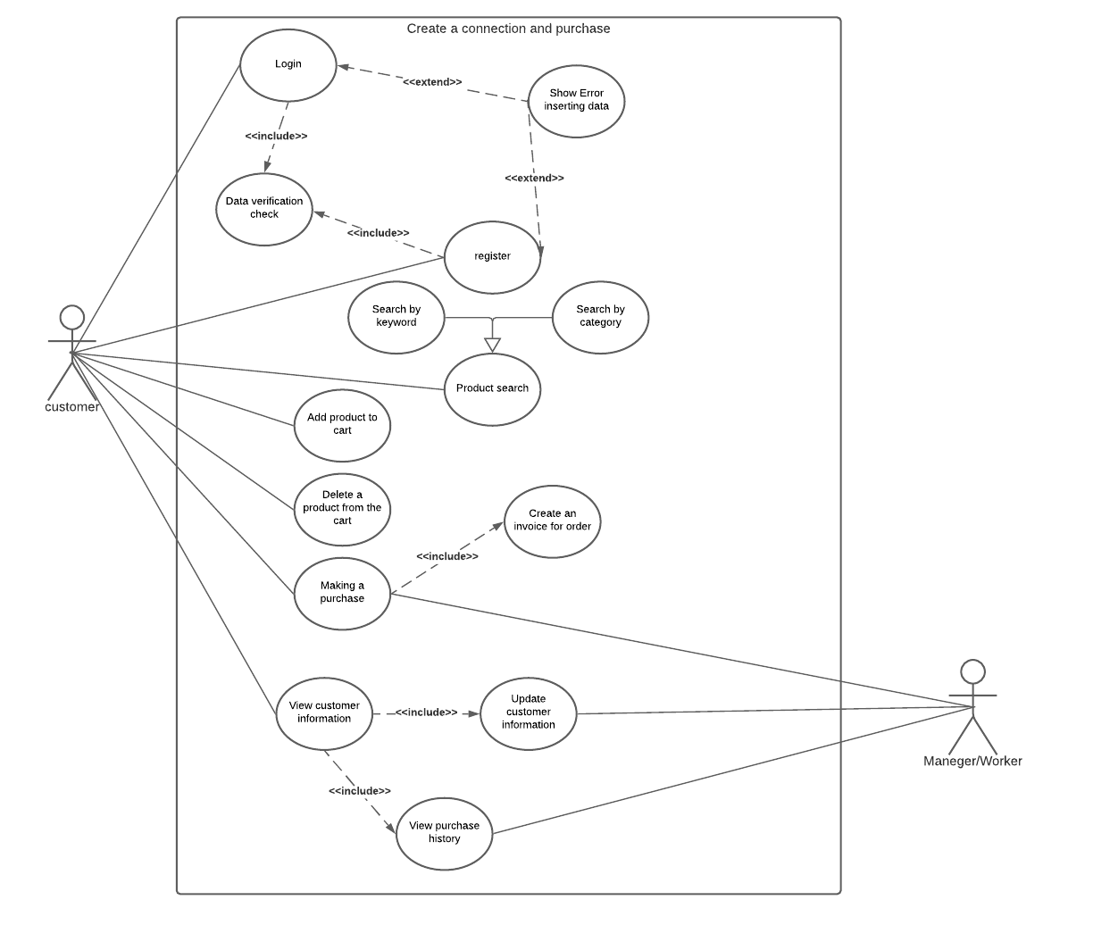](https://lucid.app/documents/edit/7d15c5b6-be4f-41dd-9d8b-64600934d5e3/0?callback=close&name=docs&callback_type=back&v=507&s=612)

* 1. Customer login If password and email match.
  2. Customer register only if the details are valid.
  3. Customer can update his details ,only if the details are valid.
  4. Customer Search existing product By keyword or category.
  5. Customer add/delete product from cart.
  6. Customer making a purchase as a result Customer and Manager/Worker can View purchase history

# activity diagram

## **Product purchase**

[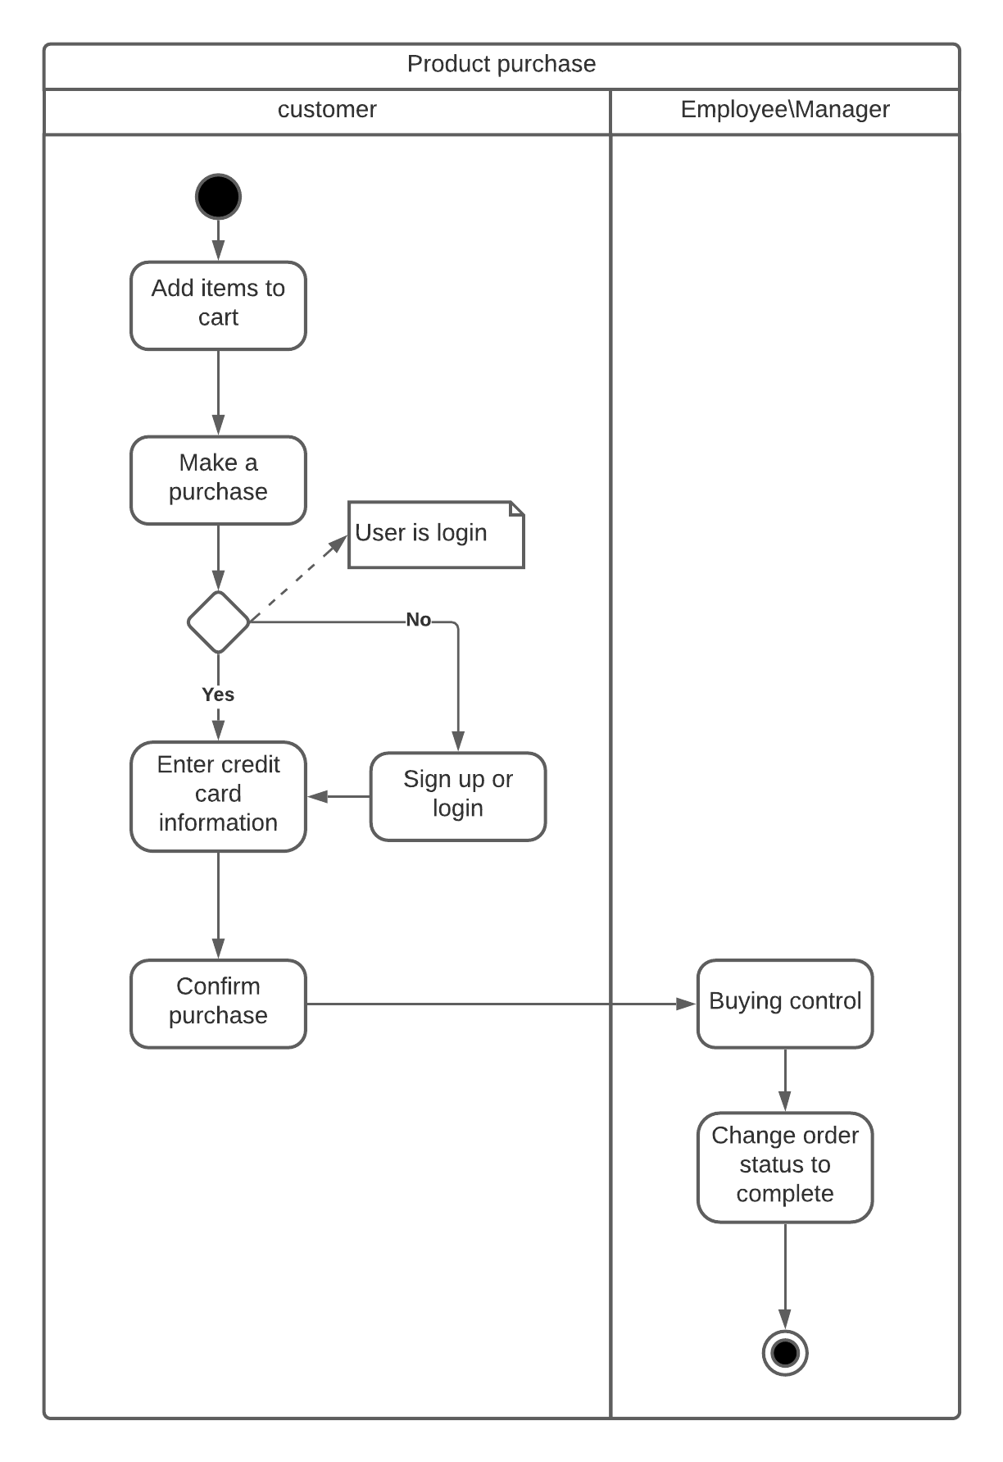](https://lucid.app/documents/edit/b14cc75e-64b2-4941-af5b-aebd520ecf10/0?callback=close&name=docs&callback_type=back&v=254&s=612)

## **Inventory management**

[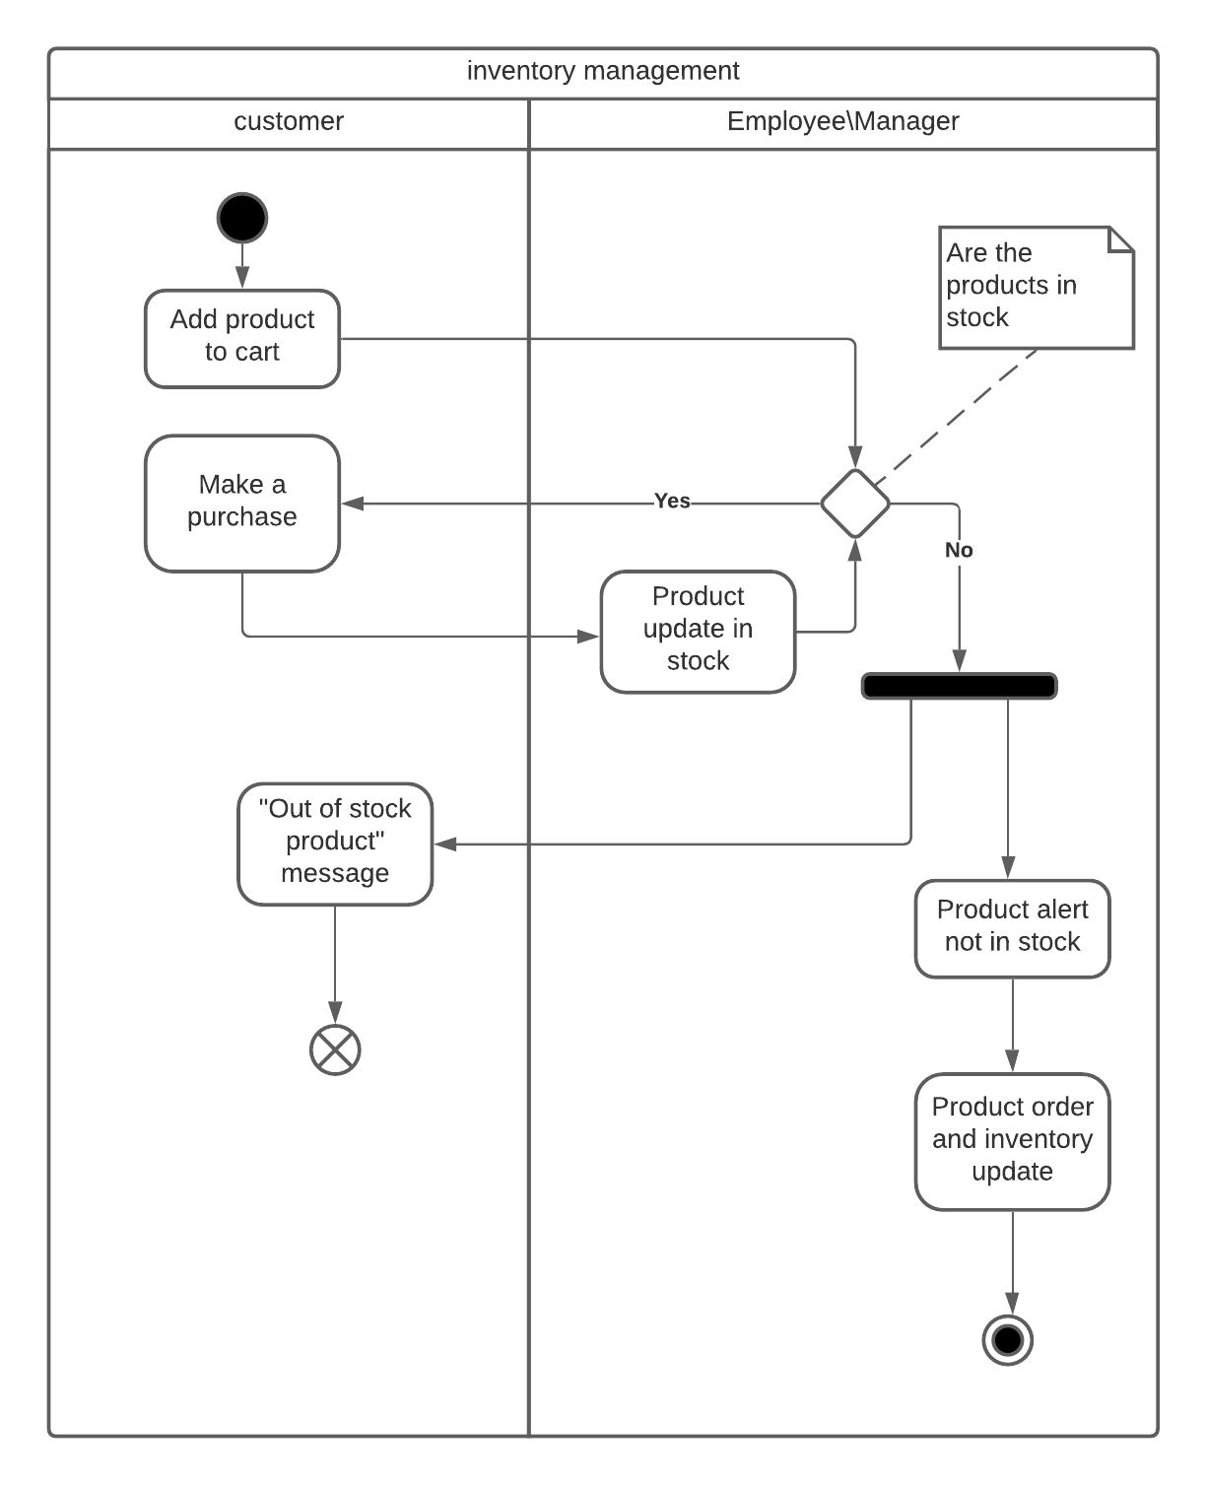](https://lucid.app/documents/edit/fb7d2480-0e8d-4970-b7f2-3e6a9e8f1e4e/0?callback=close&name=docs&callback_type=back&v=336&s=612)

# **Manual**

### Administrator's Guide

## Manager and employee entry and toolbar change



* 1. **Login:** Clicking the "Login" button on the toolbar will take you to the Login page

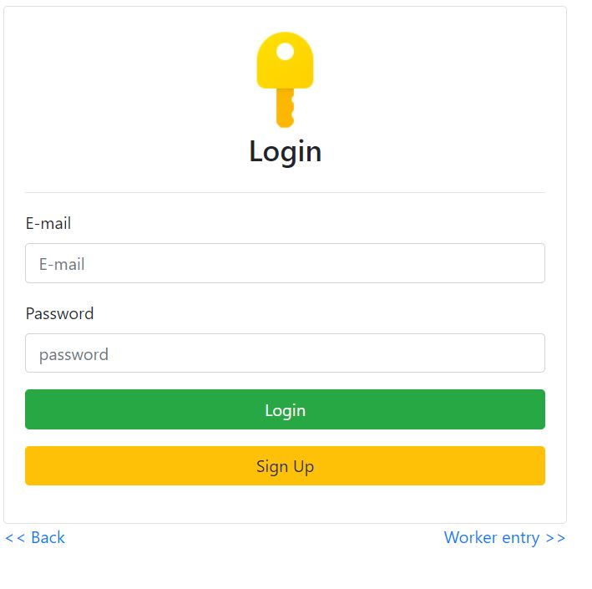

Pressed the hyperlink “Worker entry” and it will take you to the Worker Login page

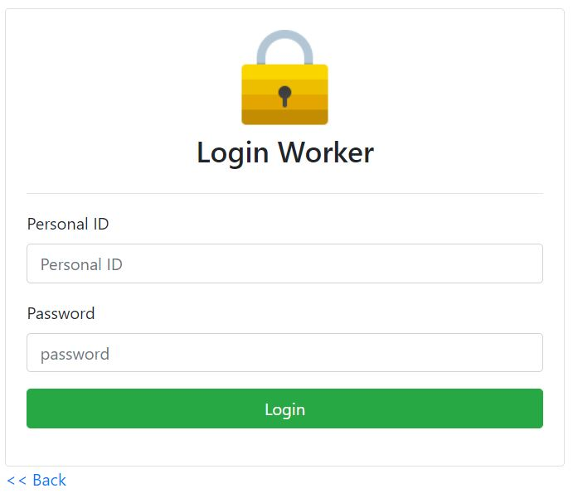

Enter personal ID number and password

The site is initialized for the administrator:

ID: 0

Password: 123456

The toolbar will change depending on the Worker’s authorization

Press “logout” button to log out

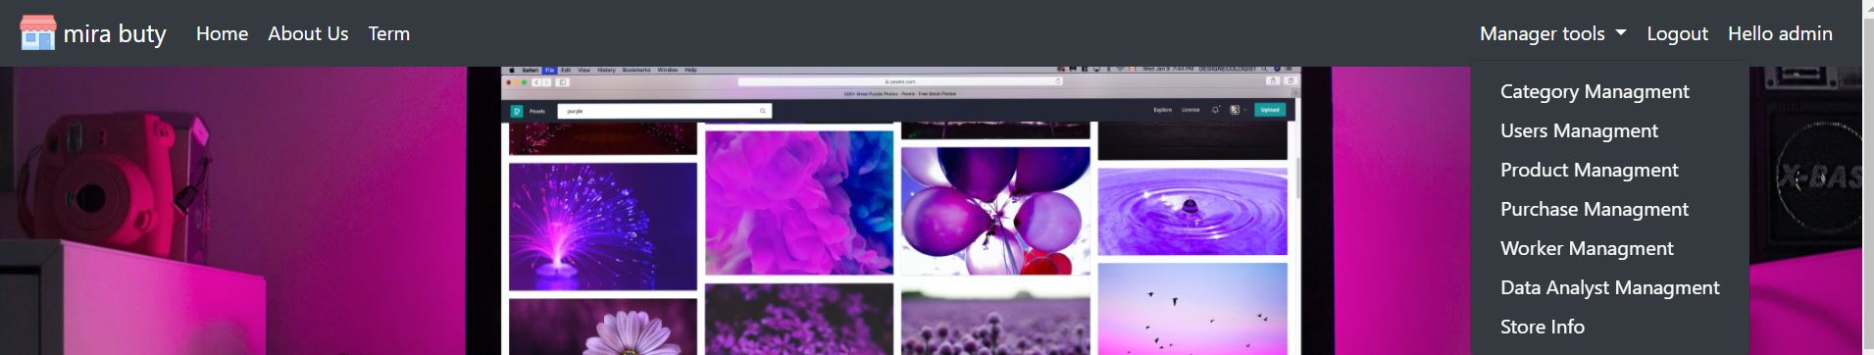

## 

## 

## Category Management

## 

## 

* 1. **Add Category:** Fill in the form as requested and if there is an error, the error will be displayed at the bottom of the page and click on “Add” button
  2. **Category update:** Select one of the categories from the list on the left by clicking the "Select" button

The ID of the category you will see in “Category ID”,Fill out the form as desired and click the "Update" button

* 1. **Delete Category:** Select one of the categories from the list on the left by clicking the "Delete" button
  2. **Search Category:** Write a search keyword, the result will be shown in the table

## 

## 

## 

## User Management

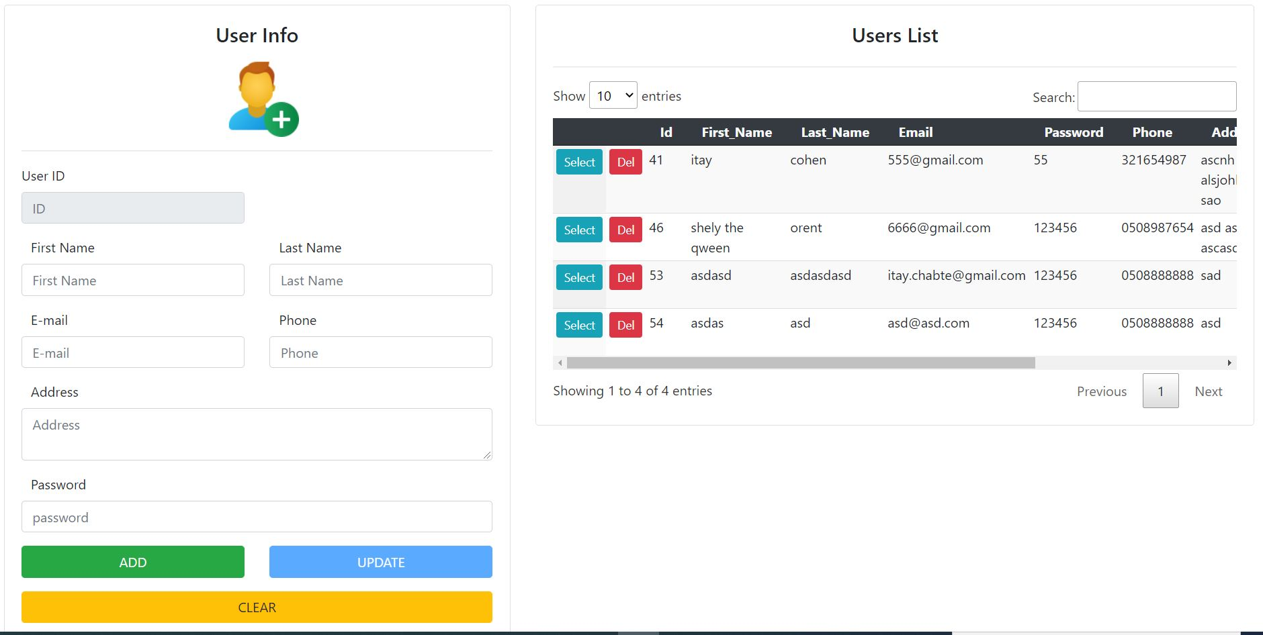

* 1. **Add User:** Fill in the form as requested and if there is an error, the error will be displayed at the bottom of the page and click on “Add" button
  2. **User update:** Select one of the user from the list on the left by clicking the "Select" button

The ID of the User you will see in “User ID”,Fill out the form as desired and click the "Update" button

* 1. **Delete User :** Select one of the user from the list on the left by clicking the "Delete" button
  2. **Search User :** Write a search keyword, the result will be shown in the table

## Product Management

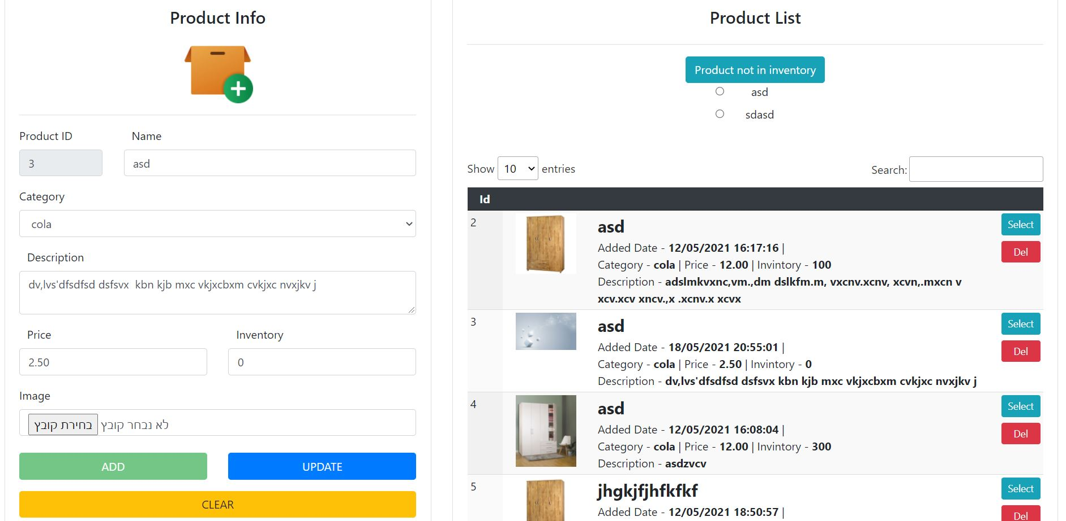

* 1. **Add Product:** Fill in the form as requested and if there is an error, the error will be displayed at the bottom of the page and click on “Add" button
  2. **Product update:** Select one of the Product from the list on the left by clicking the "Select" button

The ID of the Product you will see in “Product ID”,Fill out the form as desired and click the "Update" button

* 1. **Delete Product:** Select one of the Product from the list on the left by clicking the "Delete" button
  2. **Search Product:** Write a search keyword, the result will be shown in the table
  3. **Inventory control:** When there are products out of stock, a "Product out of stock" button will appear at the top of the table.

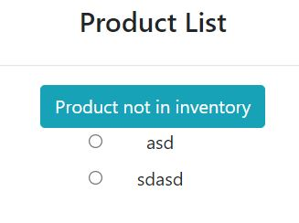

At the click of a button we get a list of products that are not in stock

By selecting one of the products we can update the product and it is dropped from the list

## Purchase Management

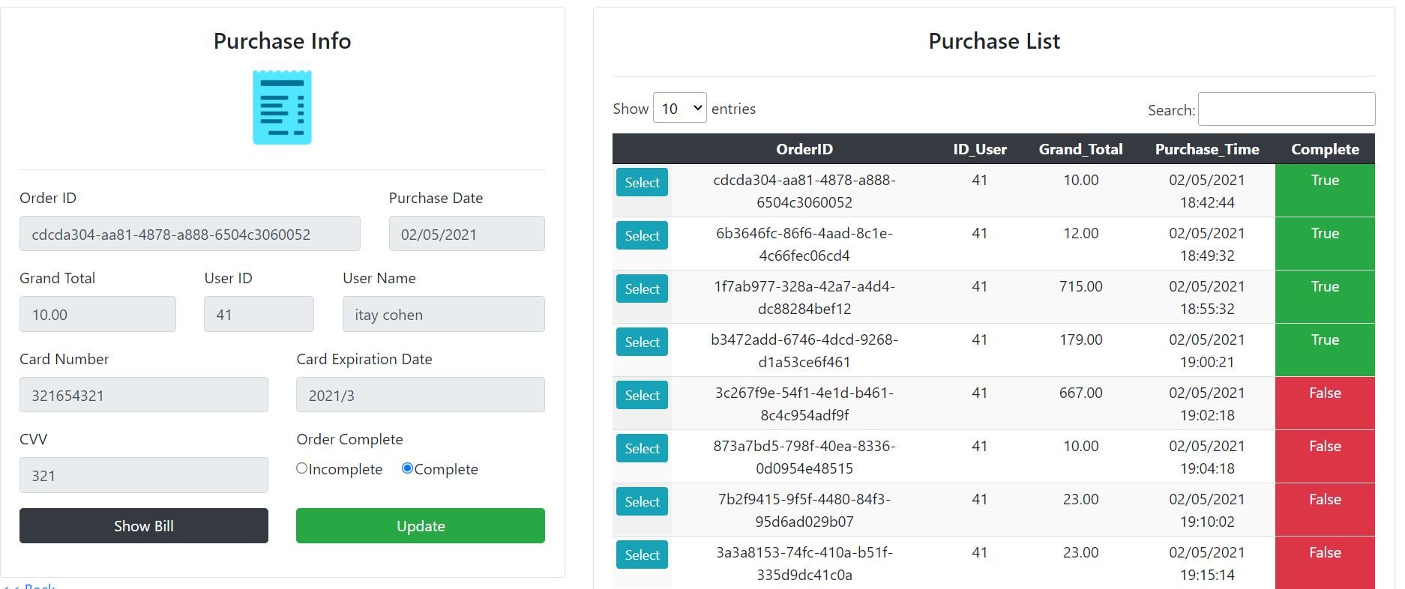

* 1. **Purchase update:** Select one of the Purchase from the list on the left by clicking the "Select" button

The ID of the Purchase you will see in “Order ID”,Choose whether the purchase is complete or not and click the "Update" button

The color in the table will change depending on the selection

Red - The order was not sent to the customer

Green - The order has been sent to the customer

* 1. **Search Purchase :** Write a search keyword, the result will be shown in the table
  2. **Show Bill:** In selecting the purchase you can click on a button ”Show Bill” and see the original invoice with all the details

You can download a PDF file of the Bill by clicking the button

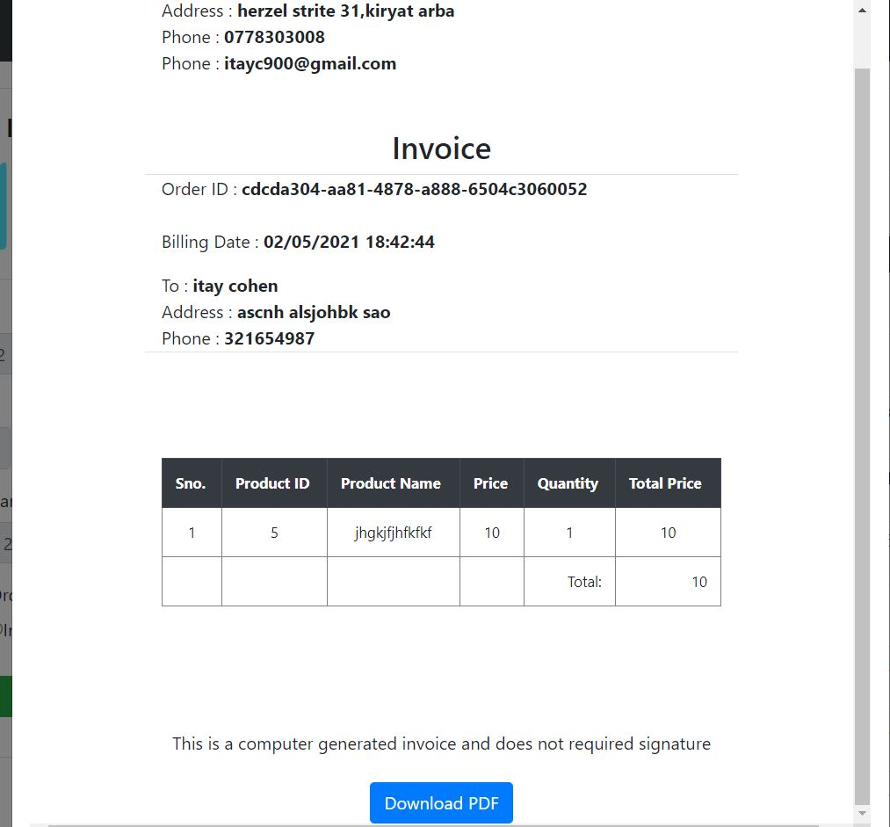

## Worker Management

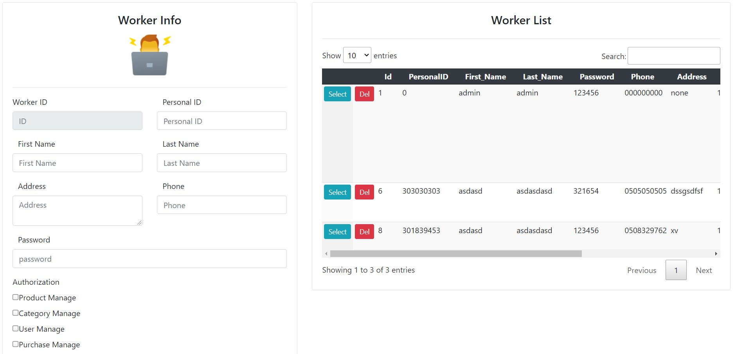

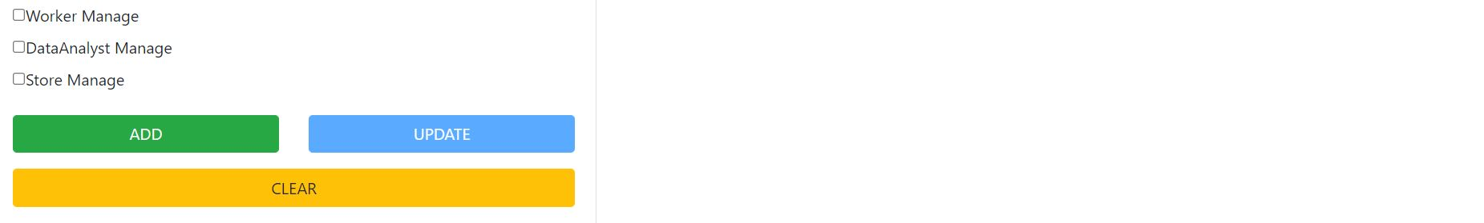

* 1. **Add Worker:** Fill in the form as requested and if there is an error, the error will be displayed at the bottom of the page and click on “Add" button

In addition to the details, we will select the permissions for each worker

Depending on the permissions the worker will get access to the various managements

* 1. **Worker update:** Select one of the worker from the list on the left by clicking the "Select" button

The ID of the worker you will see in “Worker ID”,Fill out the form as desired and click the "Update" button

* 1. **Delete Worker:** Select one of the worker from the list on the left by clicking the "Delete" button
  2. **Search Worker:** Write a search keyword, the result will be shown in the table

## Store Management

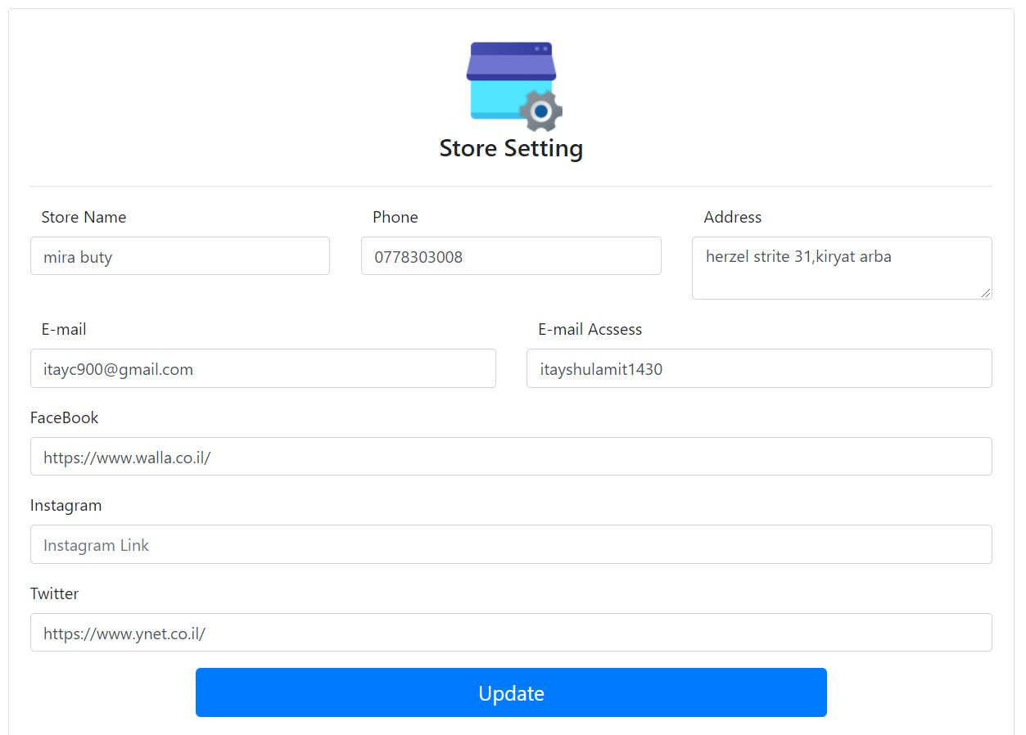

* 1. **Store update:** Fill in the details for the store

Required details:

Store name, phone, address, email, email password

Details of your choice:

Facebook

Instagram

Twitter

All changes will be seen on the site as well as in the account created for each purchase

In addition to sending an email to every new user and every purchase

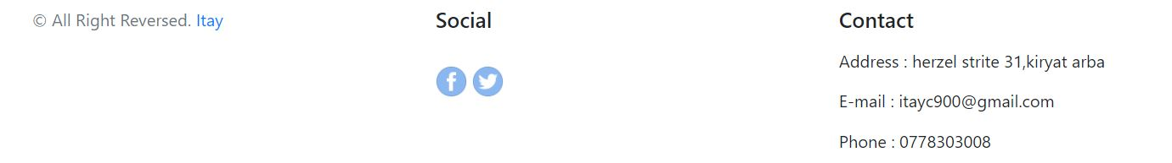

## Data Analyst Management

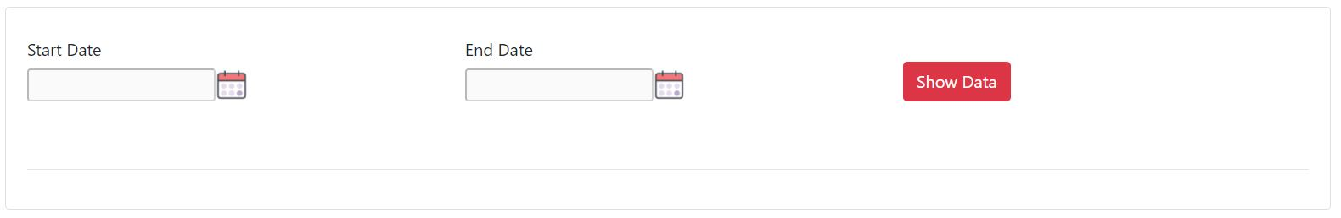

* 1. **Show data:** Select start date and end date and click the "Show Data" button

After clicking the button we will get 2 graphs

Order graph relative to time

Cake division of percentage of the sale of products

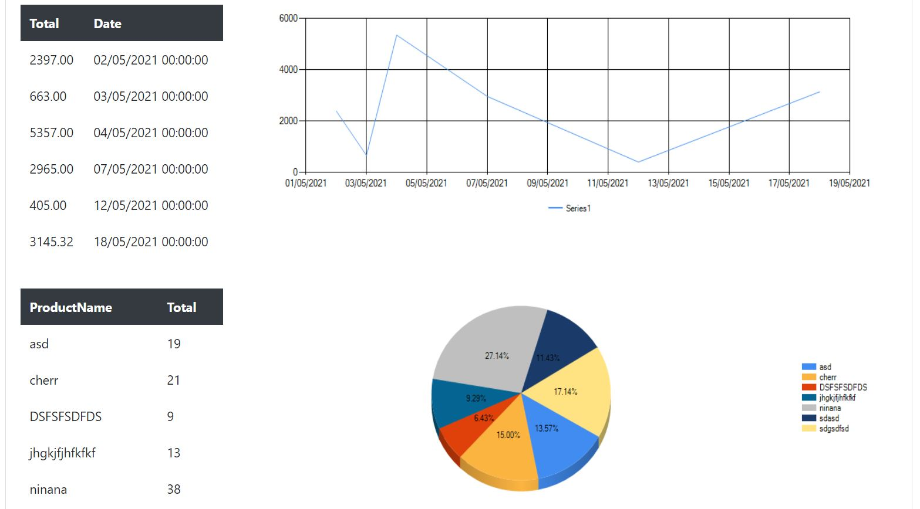

* 1. **Comparison between 2 products:** After selecting the 2 dates it will be possible to select 2 products or one for sale comparison on these dates

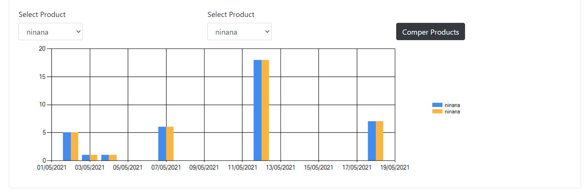

## Exception Management

When Exception is occurred we get the screen with the error details

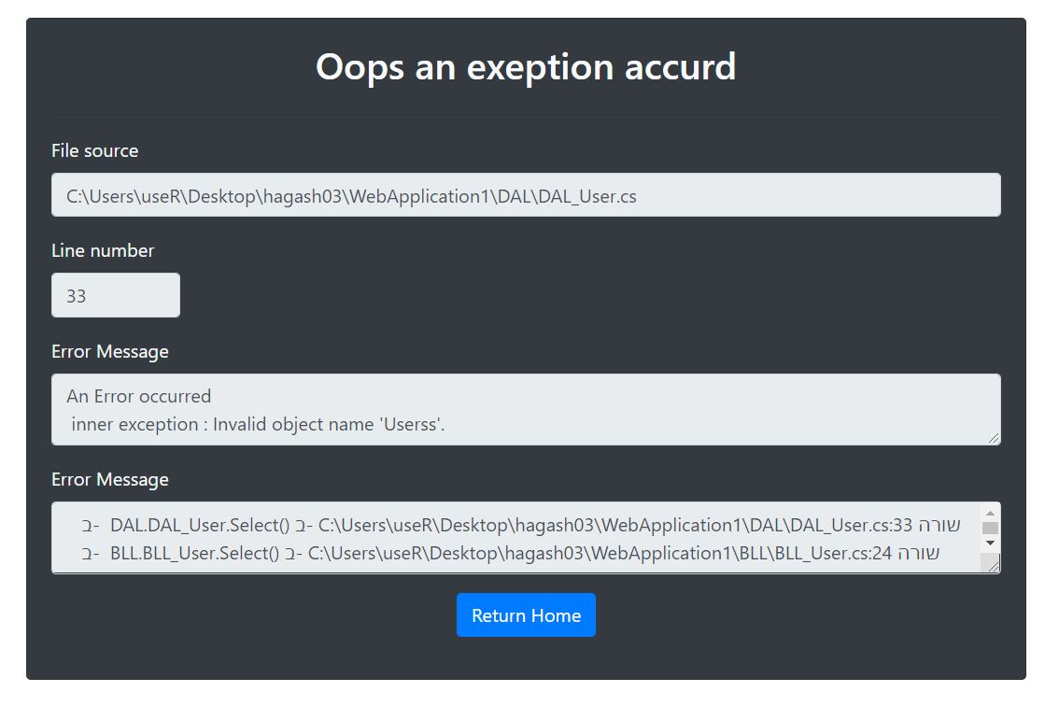

The error itself will be stored in the logError.axd file

In this case, contact the programmer with the details

### 

### 

### 

### 

### 

### 

### 

### 

### Customer’s Guide

## Manager and employee entry and toolbar change



* 1. **Login:** Clicking the "Login" button on the toolbar will take you to the Login page



Enter E-mail and password and press on “Login” button

If this is the first time on the site click on “sign Up” button

The toolbar will change to the user name

Press “logout” button to log out



## Sign up

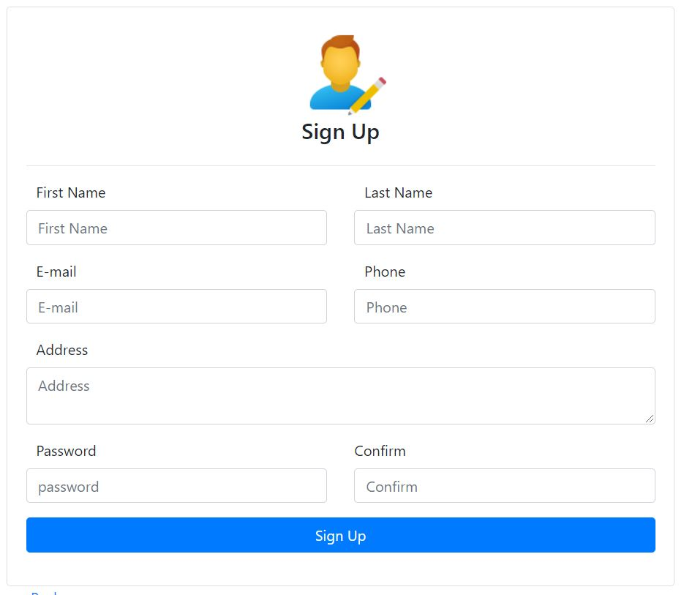

* 1. **Sign up:** Fill in the form as requested and if there is an error, the error will be displayed at the bottom of the page and click on “Sign up" button

The user will receive an email with the username and password from the site

## Profile management

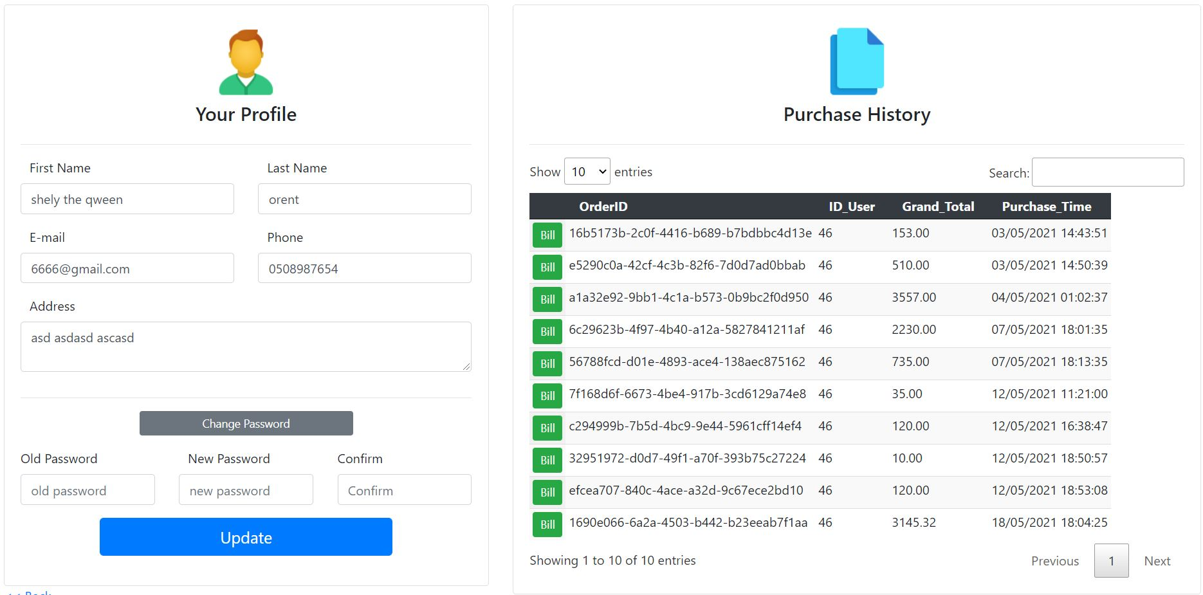

* 1. **Profile update:** When you click on the name in the toolbar, you enter the Profile Management page,the details will load automatically

The details and password can be changed individually

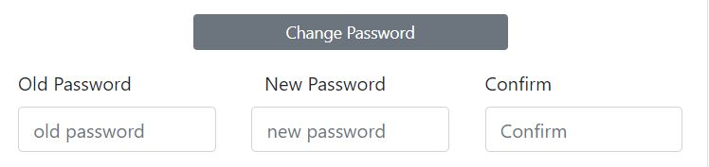

To change the password, click on the “Change Password” button and make a password change

At the end we click on the "Update" button

* 1. **Purchasing History :** Select one of the Purchase from the list on the left by clicking the "Bill" button In selecting the purchase the bill window will open with original invoice with all the details

You can download a PDF file of the Bill by clicking the button



* 1. **Search Purchase :** Write a search keyword, the result will be shown in the table

## Ordering items

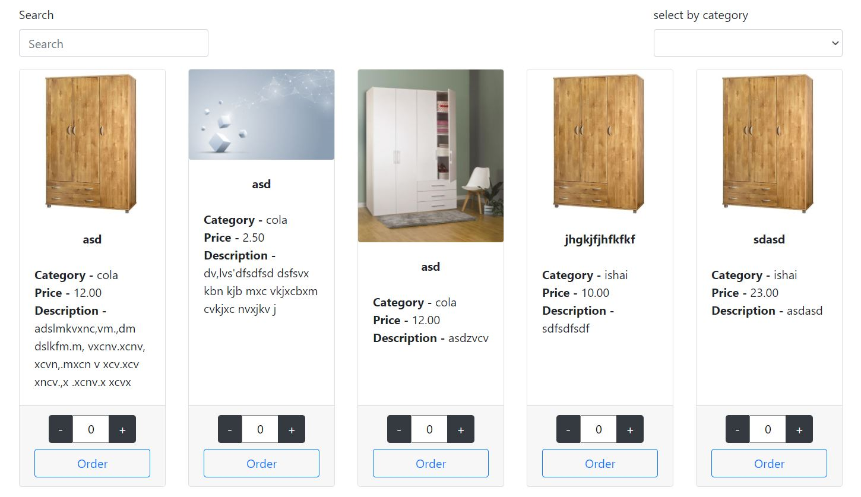

* 1. **Product search:** You can search by keyword or category
  2. **Add product to cart :** Each product appears with a name, image, price, description and category

You can select up to 20 items from each product or while stocks last

Then click the "Order" button

## Cart and purchase management

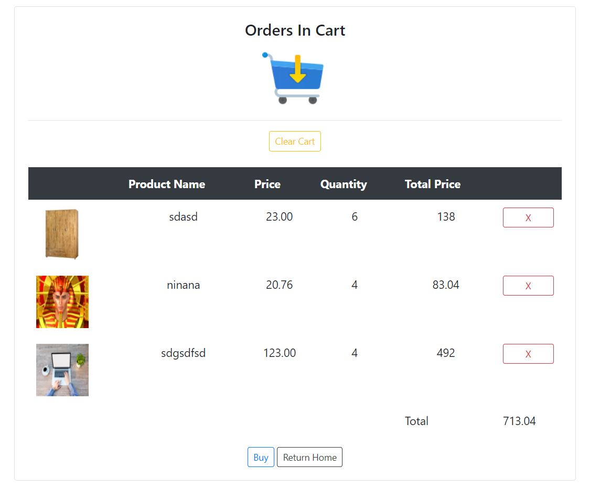

* 1. **Delete product:** Clicking on the red X will delete the product from the cart
  2. **Delete the entire product:** Clicking Clear will delete all products from the cart
  3. **Making a purchase :** Clicking on the "Buy" button will open a registration window if the user is not logged in

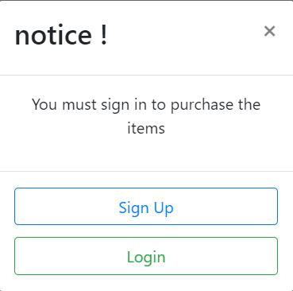

The customer will log in / register

Then we will return to the cart page and a payment window will open

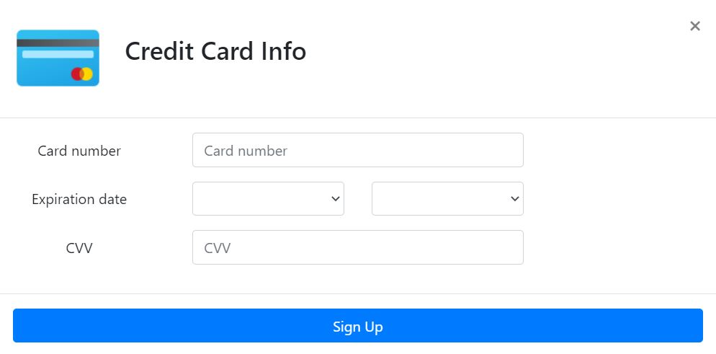

The customer will enter the credit card details where he wants to make a payment

After confirmation an invoice page will open and the order has been placed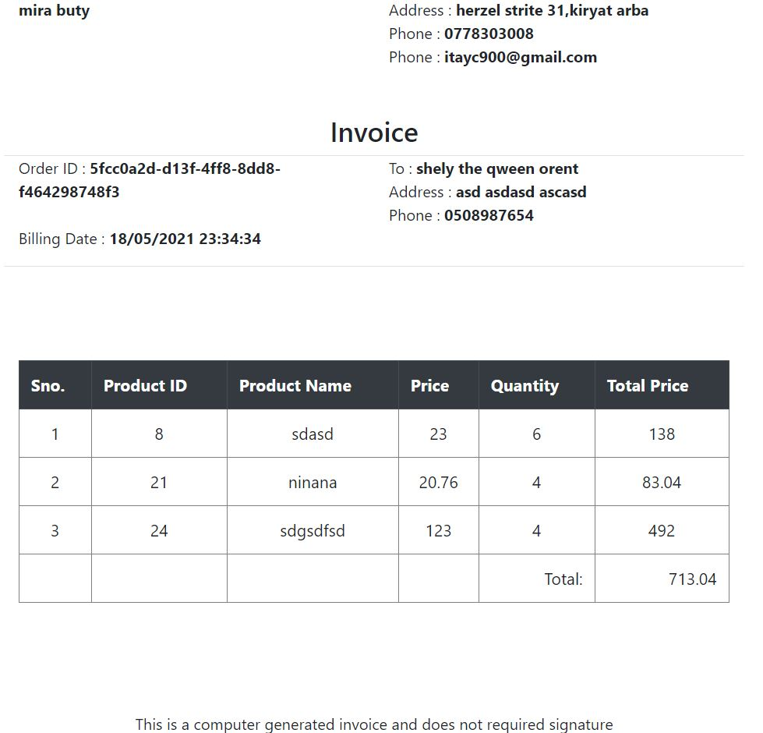

An email will be send to the customer with the order number